Senior Design I EML 4551C

Team 520: Simulated Assembly Line and Processing Workstation

Concept Generation

FAMU-FSU College of Engineering
2525 Pottsdamer St, Tallahassee, FL 32310

Team Members:
David DiMaggio: dcd14@my.fsu.edu
Cheyenne Laurel: crl15d@my.fsu.edu
Boluwatife Olabiran: boluwatife1.olabiran@famu.edu
Nataajah Taylor: nataajah1.taylor@famu.edu
Joell Williams: joell1.williams@famu.edu

Faculty Advisor:
Dr. Dorr Campbell

Sponsor:
Tallahassee Community College

Instructor:
Dr. Shayne McConomy

Concept Generation

Table 1: The table below outlines various concepts considered for each of the main function of the project.
A | B | C | D
Move Products | Detect Material | Determine Material | Sort Materials
- Conveyor Belt | - Photoelectric Sensor | - Inductive Proximity Sensor (Proxy Switch) | - Solenoid
- Roller Conveyor | 2. Limit Switch | 2. Reed Switch | 2. Mechanical Arm
- Omnidirectional Conveyor | 3.Ultrasonic Sensor | 3. Hall Effect Sensor | 3. Suction Cup (Vacuum)
 |  | 4.Capacitive Sensor | 4. Compressed Air
 |  |  | - Miniature Snap Action Switch
 |  |  | - Memory Switch
 |  |  | - Conveyor Diverter Arm/Bar
 |  |  | - Electric Actuator (Pusher Sorter)
 |  |  | - Shoe Sorters
 |  |  | - Narrow Belt Sorter
 |  |  | - Tilt Tray Sorter
 |  |  | - Cross Belt Sorter
 |  |  | - Pivot Wheel Sorter
 |  |  | - Activator Roller Belt Conveyor
 |  |  | - Paddle Divert Sorter
 |  |  | - Sweep Sorter
 |  |  | - Chain Transfers
 |  |  | - Roller Transfer
 |  |  | - Belt Under Roller Conveyor

Each column of Table 1 above represents a function to be achieved. To complete a concept, an individual concept from a column is combined with a concept each from the other columns. For example, A1-B3-C4-D2 represents a full design concept where the conveyor belt (A1) transports the material, an ultrasonic sensor (B3) detects the material for presence detection and distance estimation, a capacitive sensor (C4) then determines the nature of the product (metal, plastic, paper) and a mechanical arm (D2) then transfers the unwanted material into a bin where it is taken away from the conveyor belt. Each concept per column can be combined to get a total 3 * 3 * 4 * 19 = 684 concepts. However, some concepts will be excluded due to various reasons which will be highlighted below:
- Roller Conveyor (A2): Roller conveyor is excluded because among the materials already ordered by our sponsor is a conveyor belt. Therefore, a roller conveyor is not necessary.
- Omnidirectional Conveyor (A3): Omnidirectional conveyor is also excluded because a conveyor belt is already available. An omnidirectional conveyor is also too expensive for the purpose it is to achieve and the project in general, because that much control is not needed for the movement of the objects as they travel through various sensors.
- Narrow Belt Sorter, Cross Belt Sorter, Chain Transfers and Belt Under Roller Conveyor: these had to be excluded because they only work with Roller Conveyors; which will be excluded from the final concepts.

Here is a basic overview of some of the concepts considered:
- The design will consist of a single conveyor belt that will be responsible for moving the products most of their journey. The products will be dispensed onto the belt most likely by hand or another machine that will not be included in this project. Once the object is on the belt, it will travel through two sensors: a capacitive proximity sensor and a photoelectric sensor. The capacitive proximity sensor has a maximum sensing distance of 8 mm and will be placed first to detect the difference in material based on the capacitive difference in the materials. In order to make sure the object comes into sensing distance, a railing system will be in place to guide the objects as close to the sensor as possible to ensure the most accuracy. The other sensor, a photoelectric sensor will be placed immediately following the proximity sensor and will determine the size of the object on the belt. The railing system will then guide the objects to the far left of the conveyor belt, where a linear continuous AC solenoid will provide the physical force behind the sorting. The solenoid at the far-left side of the belt may have to be a long stroke solenoid in order to reach the distance necessary to sort the products. The bins that will collect the sorted materials will be located at the end of the line, with one set of the bins being located at y= 0 cm. The solenoid will extend out certain lengths depending on the detected material and size of the object as its way of ensuring the product makes it to the correct redirection. How far the solenoid pushes the product is key to how the system will sort. For an object to get sorted into bin 4, the solenoids will basically do no work as the railing system places the object in the correct trajectory. For an object to make it to bin 3, the solenoid will push the object just far enough past the width of bin 4, where railings will then guide the object once at the correct y position. For bins 1 and 2, a second solenoid with a mechanical arm will be responsible to sort between the two bins. It will close to have an object go to bin 1, and will remain open for the item to go into bin 2. The objective is finished once the products have reached their respective bins.

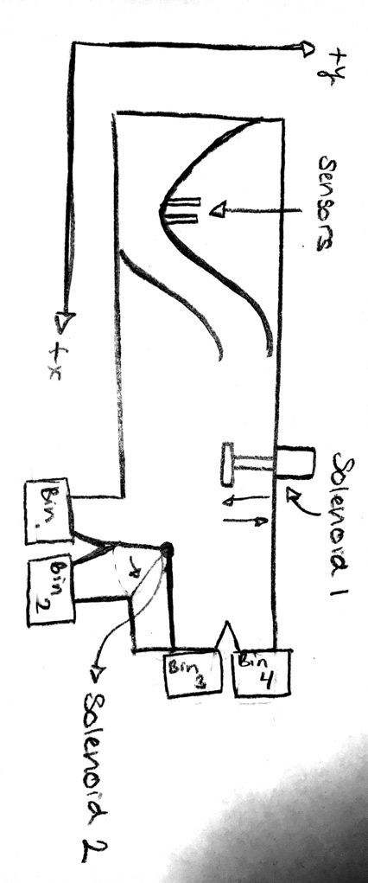
Figure 1: Schematic of Concept 1
This design has a high possibility of inaccuracy for the objects making it to their correct bins since separation relies on the precise placement within their respective, and if the object is an irregular shape, it could end up in the wrong bin. This problem is explored more in the second concept.

- The second design that may be considered feasible consists of the assembly line that will use flexible arms as a funneling system to make sure the product comes within 8 mm sensing distance for the capacitive sensor that will be placed on the other side of the railing (similar to the first design). The difference for this design is the railing with place the object back into the center of the belt instead of the far left. Once the products travel through the sensing range, and the material and size are determined, the products will reach the first sorting mechanism. It will consist of a rotating arm that covers the whole span of the belt to divide the materials based on material first. Once the object is sorted based on material, there will be two more rotating mechanical arms, powered by solenoids, within the two material sorting lines. These rotating arms will cover the span of the each of the two products lines to further sort the objects based on their detected size. This improves accuracy by closing off all other available pathways that may lead an object to the wrong bin, unlike the very open design first mentioned, that requires complicated force and timing measurements to make sure the bin lands in the correct bin.
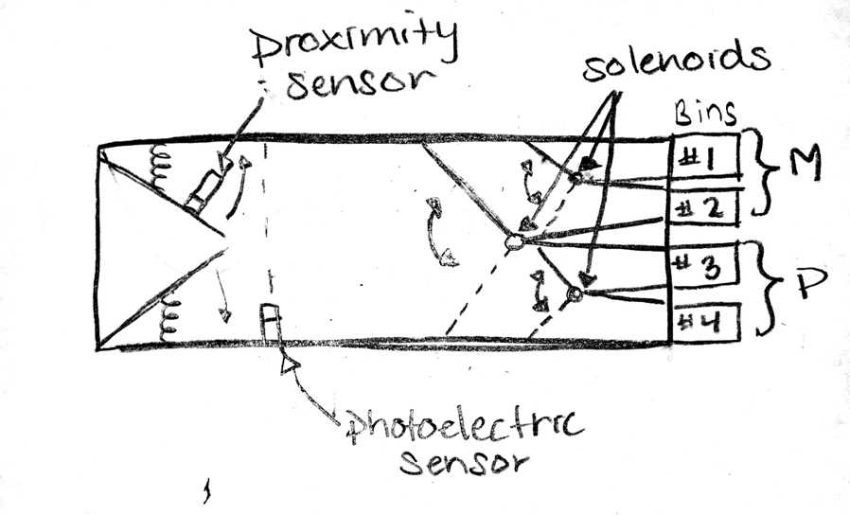
Figure 2: Schematic of Concept 2

This design increases the accuracy since sorting would no longer be affected by an irregular shaped object, however, the cost is increased due to the inclusion of a third solenoid and rotating arm. The most uncertainty remains with ensuring the objects come within the required 8 mm sensing range of the capacitive sensor.

- This concept uses the two assembly lines that have already been purchased. Positioning the smaller one normal to the bigger one and connecting them together. The green objects represent the inductive and capacitive sensors. They will be positioned below the assembly line to detect the inductance and capacitance of the object above. The blue object is the programmable logic controller (PLC) which is positioned in between the green and orange objects and is mounted to the assembly line. The orange object is what will be used to reposition the object once the PLC decides what type of material and/or the size of the object.
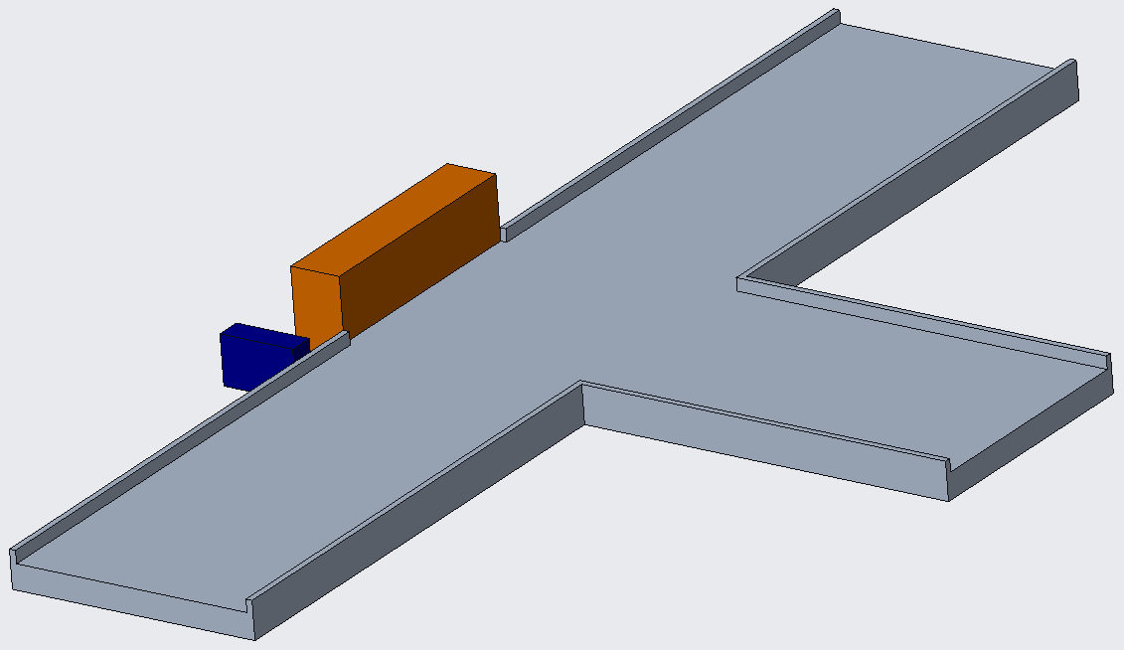
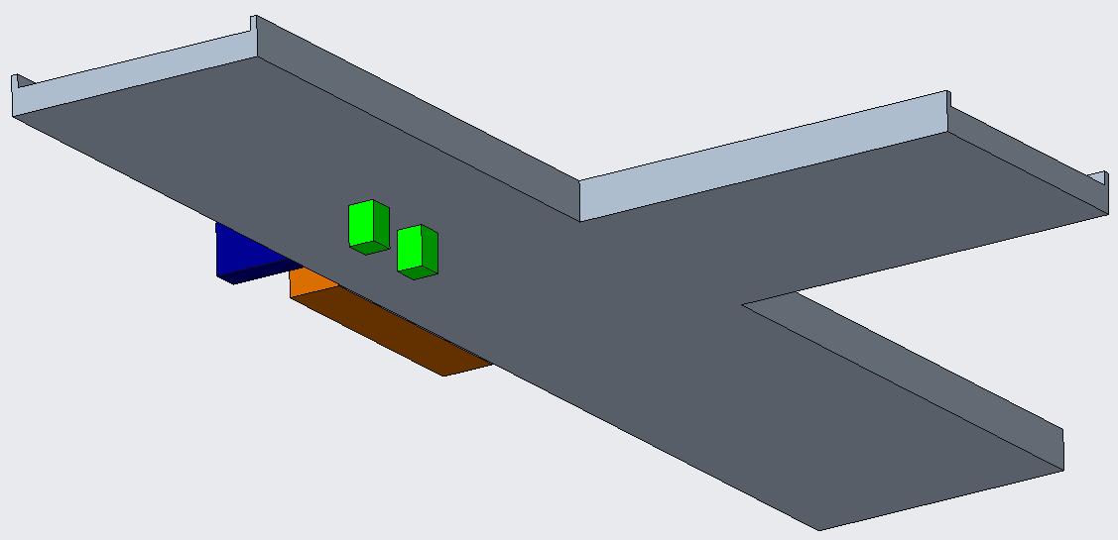

Figure 3: 3D Modeling of Concept 3

Similar rotating arms that are connected to solenoids are going to be placed further down each of the conveyor belts to further divide the objects by size. The object material can be any of that listed in column D of the table above. A major assumption with this design is that the sensors, which have a max detection distance of 8mm, can sensor the object in question through the assembly line.
- The first two sensors used will be the inductive and capacitive proximity sensors. As the objects pass the inductive sensor a solenoid will be placed to direct those objects that are not plastic to a different part of the conveyer belt, where the capacitive sensor is located and with the help of the mechanical rotating arm. If the plastic is detected the object will continue to move down the assembly line where a photoelectric sensor will be programmed to detect the size of the objects. If the object is classified as small another solenoid will be used to direct the plastic objects in the correct bin. The metal objects will then follow the same guidelines as the plastic objects in a different area of the conveyor belt. The second photoelectric sensor will be used to detect the size of the metal. The last solenoid, that must be purchased, will direct the materials based on its size. The inputs of the solenoids will come directly from the outputs of the photoelectric sensor. The photoelectric sensors will not need to know if the objects are plastic or metal because it will be based strictly on size. The first solenoid will be directly linked to the inductive sensor as it uses the output of that sensor, as input, to push non-plastic items away. Most error will occur with placing material exactly 8mm from the sensors to get them to detect the objects flowing through. This design will also include both conveyor belts purchased by the sponsors.

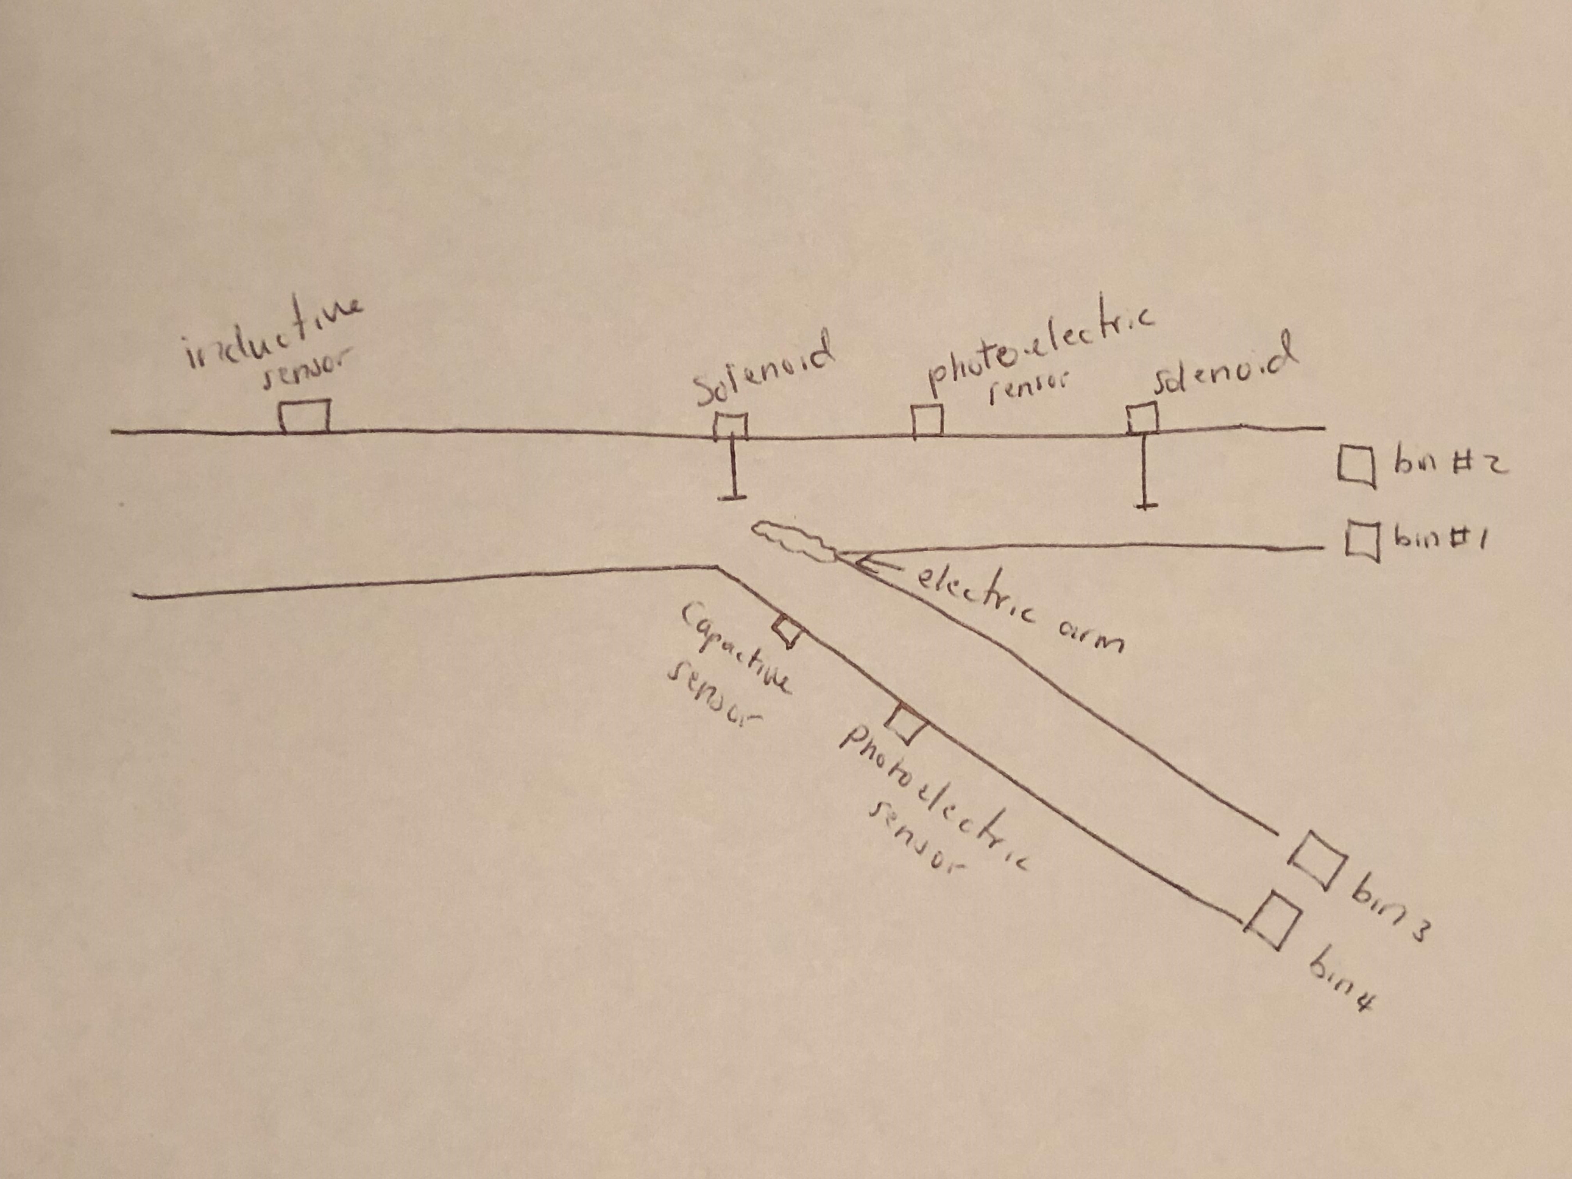
Figure 3: Schematic of Concept 4

